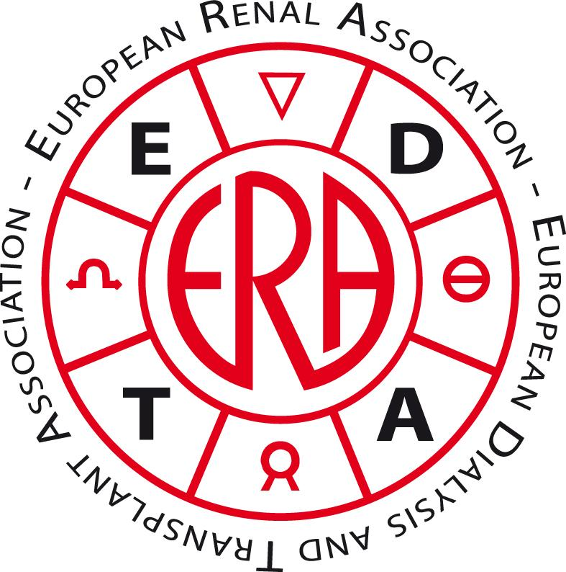

The DIAlysis and Pregnancies in EuRope (DIAPER) study
Please fill out this form and return it to Marlies Noordzij by e-mail: era-edta-study@amc.uva.nl

Name: ________________________________________________
Dialysis unit: ________________________________________________
City and country: ________________________________________________

1. How many women aged 14-44 years are currently being dialyzed in your unit? ____________

2. Did any of the chronic dialysis patients in your unit become pregnant in the period 2007 to
2011? (Conception AFTER the start of dialysis) Yes / No

If yes, number of pregnancies: ____________

3. Pregnant patients
Patient 1:
Date of birth (dd-mm-yy): ________

Pregnancy duration: ____ weeks and ____ days

Pregnancy outcome: 0 Spontaneous abortion (< 24 weeks)
0 Induced abortion
0 Still birth (foetal loss > 24 weeks)
0 Neonatal death (0-28 days after birth of live born infant)
0 Surviving infant
Remarks: _______________________________________________
If there was more than one pregnancy in your unit, please use the back of this form.

With your help we can learn about treatment during and prognosis of these pregnancies. Please help us by collecting additional data from the medical records of these pregnant patients (or ask your staff to do so). Give your e-mail address and we will send you the data collection form.
E-mail: ________________________________________________
Thank you very much for your valuable contribution!
Patient 2:
Date of birth (dd-mm-yy): ________

Pregnancy duration: ____ weeks and ____ days

Pregnancy outcome: 0 Spontaneous abortion (< 24 weeks)
0 Induced abortion
0 Still birth (foetal loss > 24 weeks)
0 Neonatal death (0-28 days after birth of live born infant)
0 Surviving infant
Remarks: _______________________________________________

Patient 3:
Date of birth (dd-mm-yy): ________

Pregnancy duration: ____ weeks and ____ days

Pregnancy outcome: 0 Spontaneous abortion (< 24 weeks)
0 Induced abortion
0 Still birth (foetal loss > 24 weeks)
0 Neonatal death (0-28 days after birth of live born infant)
0 Surviving infant
Remarks: _______________________________________________

Patient 4:
Date of birth (dd-mm-yy): ________

Pregnancy duration: ____ weeks and ____ days

Pregnancy outcome: 0 Spontaneous abortion (< 24 weeks)
0 Induced abortion
0 Still birth (foetal loss > 24 weeks)
0 Neonatal death (0-28 days after birth of live born infant)
0 Surviving infant
Remarks: _______________________________________________

